COL774 ASSIGNMENT 3 REPORT

By Khyateeswar Naidu Nalla

2019CS10376

Question 1

1. Train accuracy: 92.32%

Test accuracy: 68.77%

Validation accuracy: 76.03%

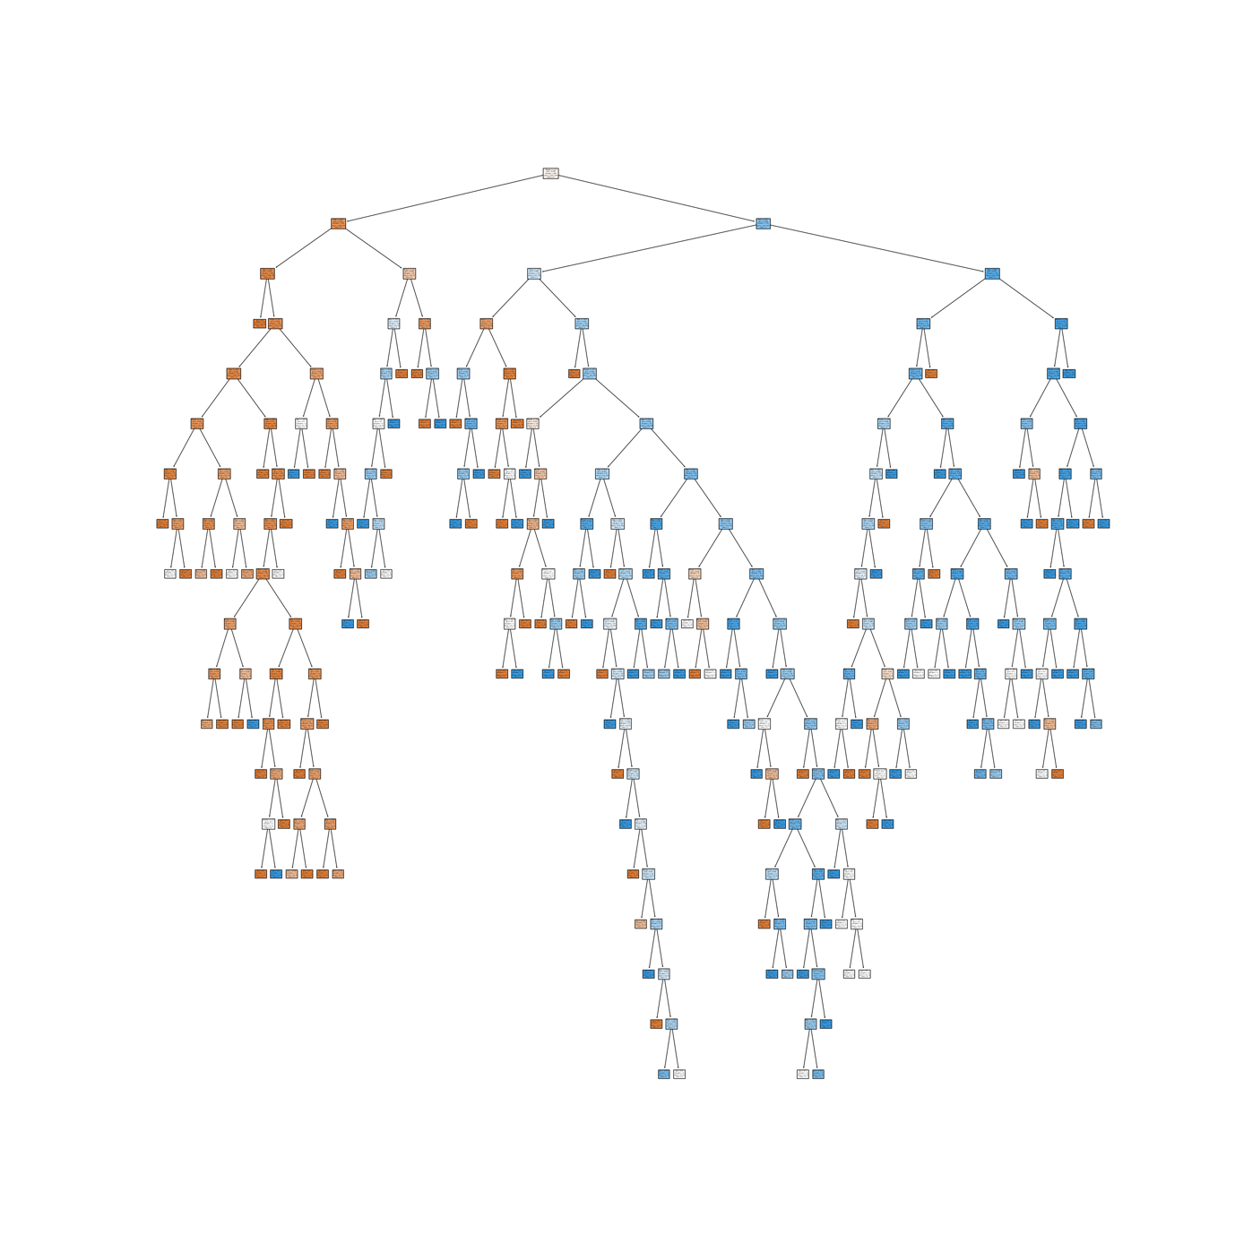

1. Train accuracy: 92.32%

Test accuracy: 68.77%

Validation accuracy: 77.68%

Optimum parameters:

Max_depth: 13

Min_samples_split: 2

Min_samples_leaf: 3

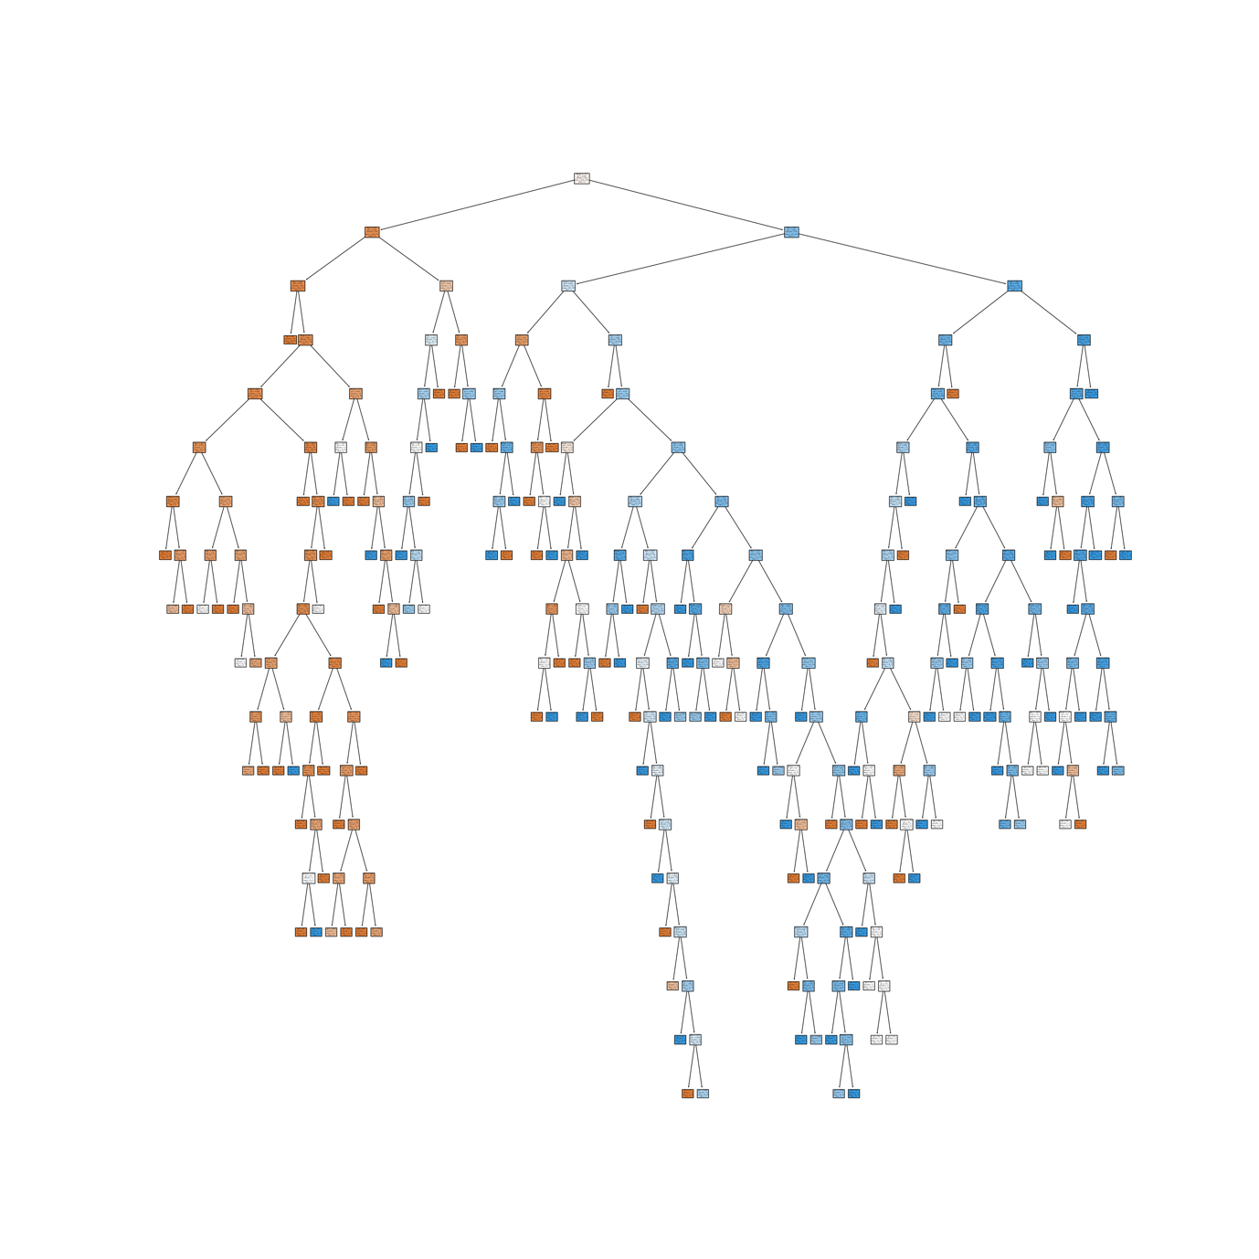

1. Train accuracy: 78.02%

Test accuracy: 77.86%

Validation accuracy: 86.23%

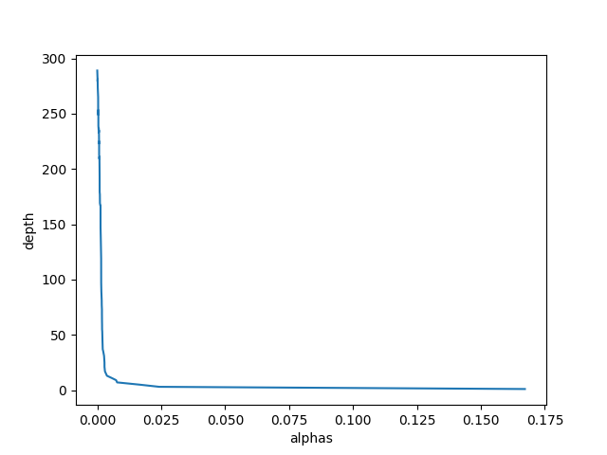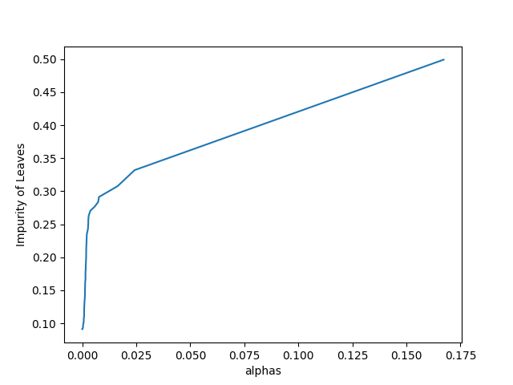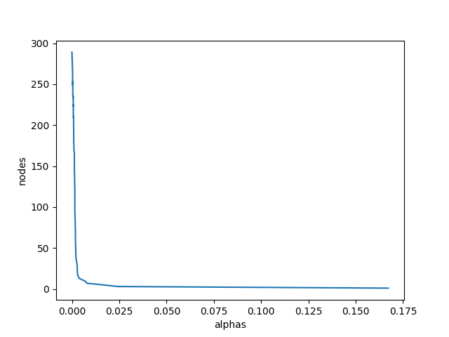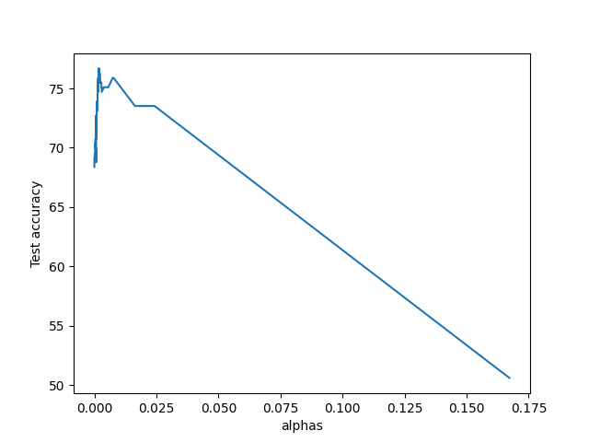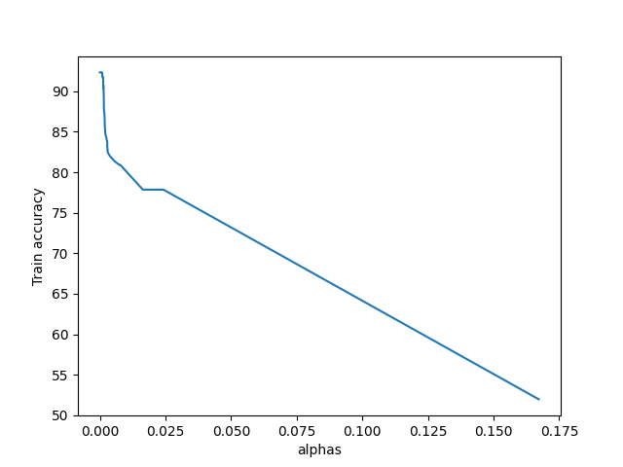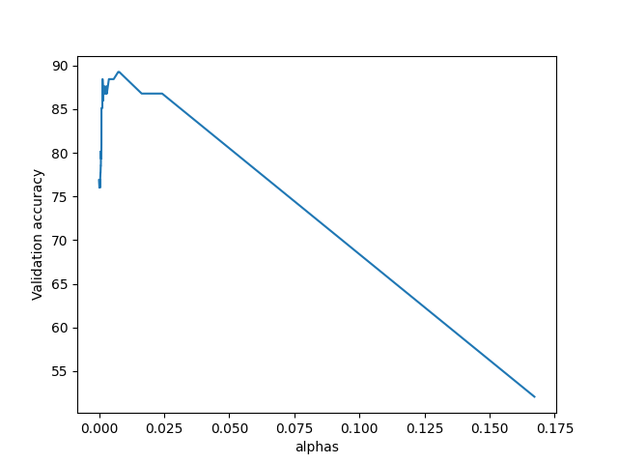

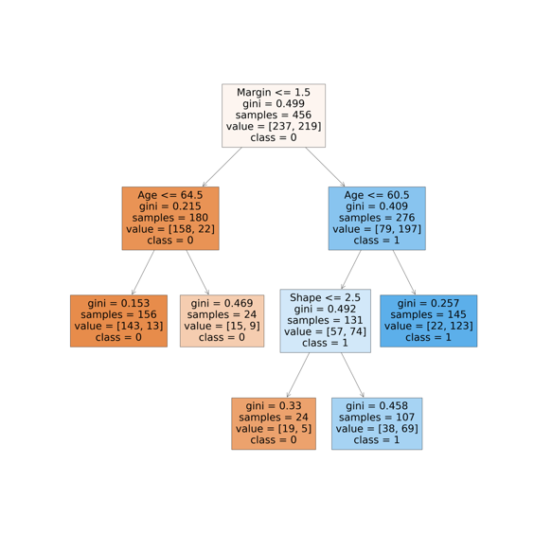

d)Train accuracy: 86.84%

Test accuracy: 77.47%

Validation accuracy: 82.64%

Oob score: 78.02

e)

a)For Median Case:

1. Train accuracy: 91.80%

Test accuracy:73.61%

Validation accuracy:73.33%

1. Train accuracy: 81.56%

Test accuracy: 80.90%

Validation accuracy: 87.40%

Optimal parameters: (max_depth, min_samples_split, min_samples_leaf) = (4,2,3)

1. Train accuracy: 80.26%

Test accuracy: 79.16%

Validation accuracy: 87.40%

1. Train accuracy: 86.96%

Test accuracy: 78.47%

Validation accuracy: 85.18%

*OOB score: 0.7635*

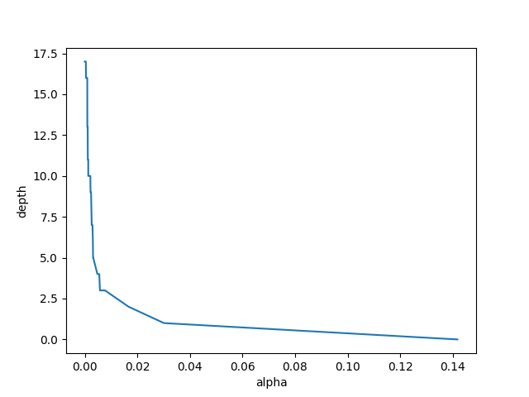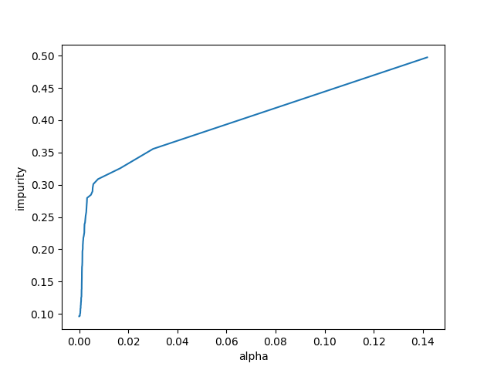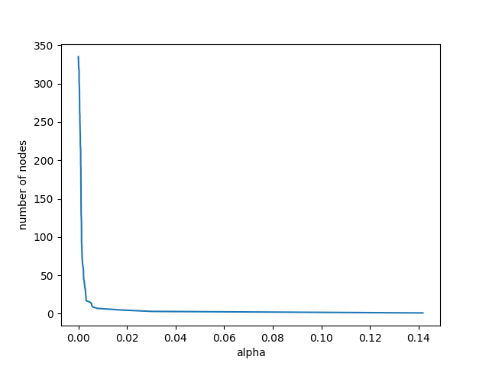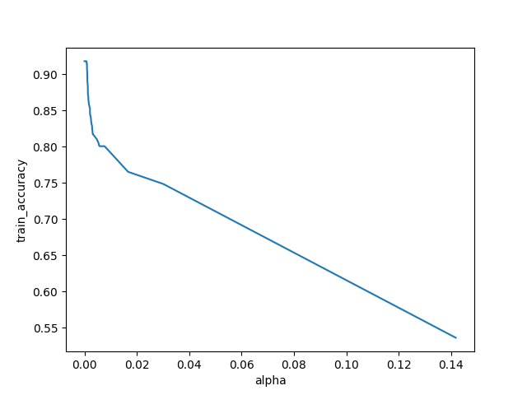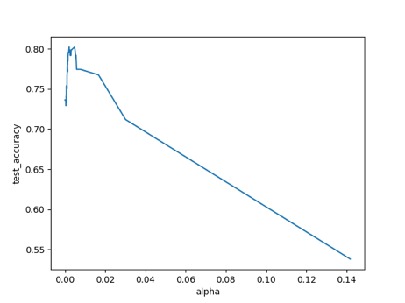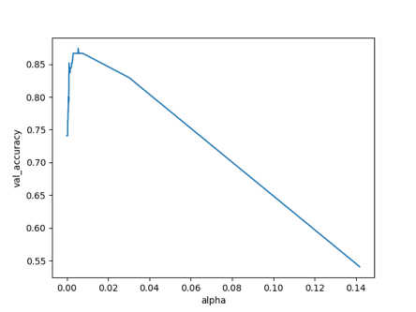

For Mode Case:

1. Train accuracy: 90.68%

Test accuracy: 73.95%

Validation accuracy:76.29%

1. Train accuracy: 80.44%

Test accuracy: 80.55%

Validation accuracy: 86.66%

Optimal parameters: (max_depth, min_samples_split, min_samples_leaf) = (4,2,3)

1. Train accuracy: 80.26%

Test accuracy:80.20%

Validation accuracy:85.92%

1. Train accuracy: 84.91%

Test accuracy: 76.04%

Validation accuracy: 84.44%

OOB score: 0.7243

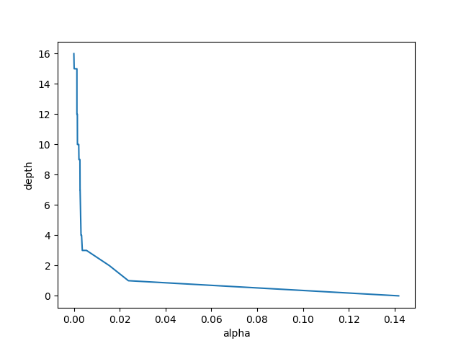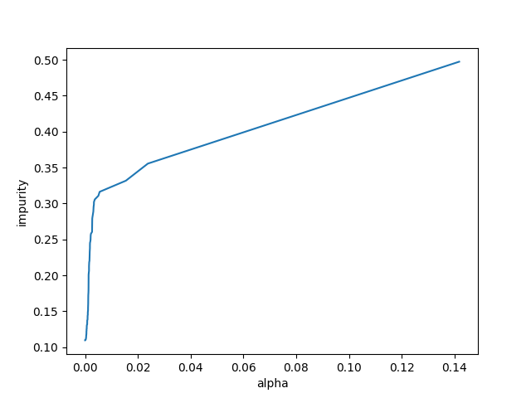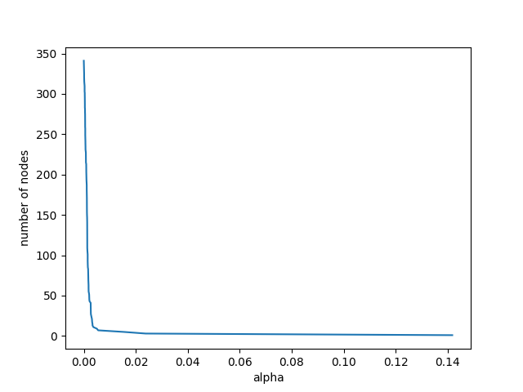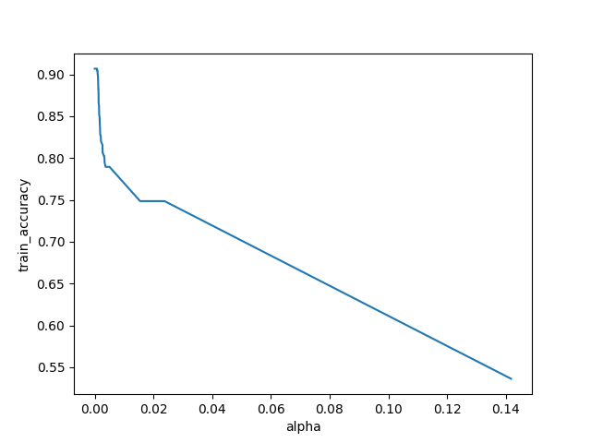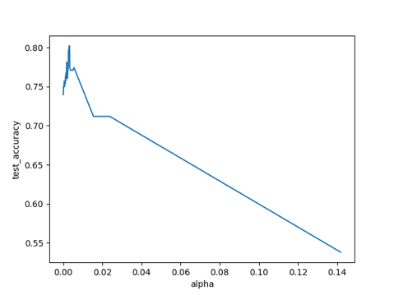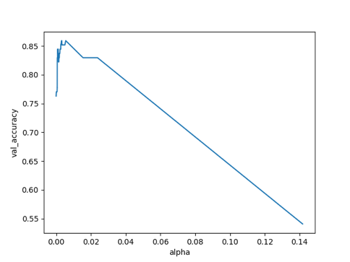

f) Train accuracy: 81.37%

Test accuracy: 76.38%

Validation accuracy: 86.67%

Question 2

a)

Train accuracy: 92.30%

Test accuracy: 57.53%

Validation accuracy: 57.23%

b)

c)

d)

e)

Question 3

b)

Stopping criteria : J(Θ)-J_prev(Θ)>0.0002

No of Hidden Units = 5

Train accuracy: 82.84%

Test accuracy: 80.5%

Confusion matrix for test

[[728, 7, 17, 84, 6, 1, 143, 2, 12, 0],

[0, 946, 11, 26, 5, 0, 8, 0, 3, 1],

[13, 9, 640, 14, 163, 12, 134, 6, 9, 0],

[32, 16, 6, 815, 36, 3, 71, 1, 19, 1],

[2, 3, 84, 21, 779, 2, 80, 2, 27, 0],

[0, 0, 1, 5, 0, 854, 3, 74, 16, 47],

[125, 3, 81, 49, 141, 5, 564, 3, 28, 1],

[0, 0, 0, 0, 0, 45, 0, 897, 3, 55],

[1, 0, 3, 19, 7, 17, 33, 15, 904, 1],

[0, 0, 0, 0, 0, 35, 2, 39, 1, 923]]]]

No of Hidden Units = 10

Train accuracy: 84.48%

Test accuracy: 82.21%

Confusion matrix for test

[[809, 0, 13, 63, 4, 2, 95, 1, 9, 4],

[2, 946, 9, 25, 9, 0, 2, 6, 1, 0],

[9, 2, 654, 23, 188, 5, 107, 1, 11, 0],

[28, 8, 6, 849, 48, 3, 45, 6, 7, 0],

[2, 1, 87, 39, 806, 7, 45, 1, 12, 0],

[3, 0, 1, 3, 0, 879, 1, 62, 14, 37],

[176, 0, 88, 50, 145, 2, 499, 2, 38, 0],

[0, 0, 0, 0, 0, 25, 0, 958, 0, 17],

[4, 0, 11, 7, 15, 13, 36, 17, 895, 2],

[0, 0, 0, 1, 0, 7, 0, 65, 1, 926]]]

No of Hidden Units: 15

Train accuracy: 86.21%

Test accuracy: 82.71%

Confusion matrix for test

[[723, 2, 25, 68, 8, 6, 155, 1, 12, 0],

[6, 953, 6, 24, 8, 1, 1, 0, 1, 0],

[14, 5, 732, 11, 108, 3, 122, 0, 5, 0],

[21, 18, 28, 825, 41, 3, 59, 1, 3, 1],

[0, 5, 136, 24, 687, 1, 135, 1, 11, 0],

[0, 0, 1, 0, 0, 913, 1, 41, 8, 36],

[115, 1, 100, 45, 80, 1, 636, 1, 21, 0],

[0, 0, 0, 0, 0, 33, 0, 935, 0, 32],

[2, 0, 5, 8, 5, 5, 28, 10, 936, 1],

[0, 0, 0, 0, 0, 23, 0, 45, 1, 931]]]

No of Hidden units: 20

Train accuracy: 85.88%

Test accuracy: 82.44%

Confusion matrix for test

[[801, 4, 31, 69, 7, 3, 75, 0, 7, 3],

[9, 957, 3, 20, 6, 1, 2, 0, 0, 2],

[9, 13, 732, 19, 133, 2, 87, 0, 4, 1],

[36, 22, 18, 858, 42, 2, 17, 0, 4, 1],

[2, 9, 130, 45, 741, 1, 62, 0, 9, 1],

[3, 0, 1, 3, 0, 907, 5, 43, 14, 24],

[175, 2, 127, 74, 122, 1, 478, 0, 18, 3],

[0, 0, 0, 0, 0, 22, 0, 959, 0, 19],

[6, 0, 15, 22, 9, 14, 28, 7, 895, 4],

[0, 0, 0, 1, 0, 16, 1, 63, 3, 916]]]

No of Hidden units: 25

Train accuracy: 88.01%

Test accuracy: 84.74%

Confusion matrix for test

[[828, 1, 26, 53, 11, 1, 66, 0, 14, 0],

[4, 955, 7, 22, 6, 0, 3, 1, 1, 1],

[18, 4, 754, 16, 143, 3, 51, 0, 11, 0],

[34, 18, 21, 861, 33, 2, 22, 0, 8, 1],

[1, 2, 94, 37, 815, 5, 39, 0, 7, 0],

[1, 0, 1, 0, 0, 927, 0, 40, 6, 25],

[180, 0, 119, 32, 144, 1, 502, 0, 20, 2],

[0, 0, 0, 0, 0, 18, 0, 955, 0, 27],

[6, 0, 5, 13, 0, 12, 12, 8, 942, 2],

[0, 0, 0, 1, 0, 15, 1, 45, 3, 935]]]

c)

For adaptive learning rate case

Stopping criteria : J(Θ)-J_prev(Θ)>0.0002

No of Hidden units = 5

Train accuracy:70.31

Test accuracy: 70.4

Confusion matrix for test set:

No of Hidden units = 10

Train accuracy:72.42

Test accuracy: 72.86

Run time: 742.85 s

Confusion matrix for test set:

No of Hidden units = 15

Train accuracy:78.55

Test accuracy: 78.34

Confusion matrix for test set:

No of Hidden units = 20

Train accuracy:79.50

Test accuracy: 79.52

Confusion matrix for test set:

No of Hidden units = 25

Train accuracy:80.38

Test accuracy: 80.49

Confusion matrix for test set:

d)

Using RELU:

train accuracy = 0.85395

test accuracy = 0.8544

Confusion matrix for test set:

Using sigmoid:

train accuracy = 0.7851833333333333

test accuracy = 0.7884

confusion matrix for test data:

e)

Accuracy plots for both train and test sets: (Orange-test, Blue-Train)

For RELU:

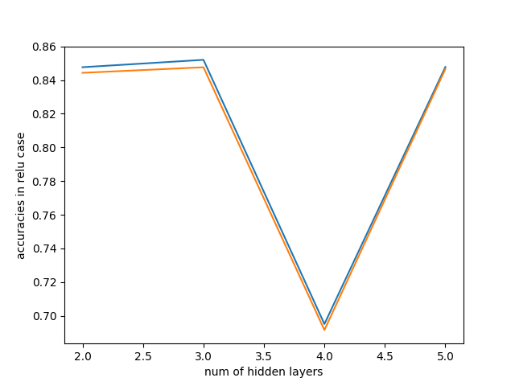

For Sigmoid:

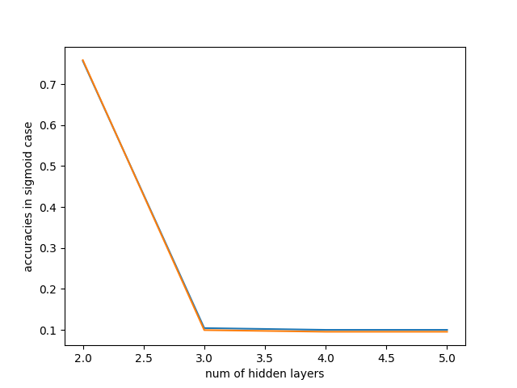

Got best test accuracy for 1 hidden layer and 35 units

f)

g) Using MLPClassfier with 1 hidden layer and with 35 units

using RELU

Train accuracy = 99.28%

Test accuracy = 88.38%

Using Sigmoid function

Train accuracy = 99.64%

Test accuracy = 87.86%